**Objective Question:**

1. **What is the total no. of tables present in the data?**

**Ans.** Total no of tables present in :-

Raw Data = 1

Pivot sheet = 9

1. **What is the total no. of attributes present in the data?**

**Ans.** Total no of attributes present in

Raw data sheet = 40.

Pivot Data sheet = 16

1. **The data consists of some inconsistent and missing values so ensure that the data used for further analysis is cleaned.**

**Ans.** Yes cleaned them by using following functions:-

Trim:- Using trim function I cleaned the extra white spaces wherever they are present in the raw data.

Isblank:- Using this function I filled up blank cells so that while perofming calculation it does not throw any unwanted results.

Proper:- Using proper function I made the Guru’s name in proper format.

1. **What is the average daily call volume over the day by day and what’s the change on it?**

**Ans** Average call volume on

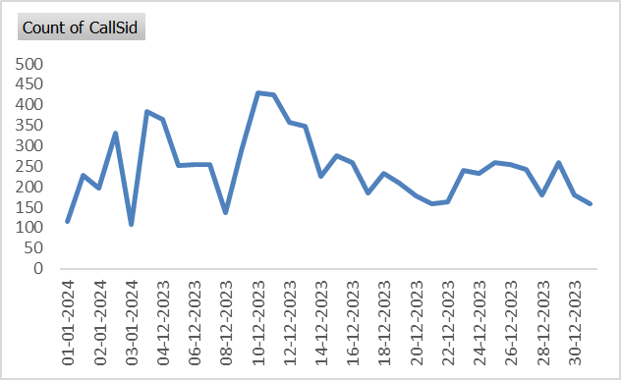

|  |  |
| --- | --- |
| Total No. of Days | 34 |
| Total Call Volume | 8365 |
| Avg Calls per day | 250.24 |

1. **Which months experienced the highest and lowest call volumes?**

**Ans.** December experienced the highest call volume with the amount of 8090 and January experienced the total of 418 call volume. So December experienced the highest call volume while January face the lowest call volume.

|  |  |
| --- | --- |
| **Row Labels** | **Sum of Call Volume** |
| Jan | 418 |
| Dec | 8090 |
| **Grand Total** | **8508** |

1. **What is the total operational cost for that month?**

**Ans.** Total operational cost was Rs. 213987.

For December :- Rs. 202214.26

For January :- Rs. 11772.69

|  |  |
| --- | --- |
| **Row Labels** | **Sum of NetAmount** |
| Jan | 11772.69 |
| Dec | 202214.6253 |
| **Grand Total** | **213987.3153** |

1. **What is the average number of calls handled per agent per day?**

To Calculate the average number of calls per agent per day by summing the number of calls per day for all agents and dividing it by the number of agents and the number of days present in the database.

**Average Calls per agent per day** = Calls handled by all Agents / Number of agents * Number of Days

= 8508 / (131 * 34) = 1.75

|  |  |
| --- | --- |
| Total No. of Days | 34 |
| Total Call Volume | 8508 |
| Number of Agents | 131 |
| Avg Number of calls | 1.69 |

1. **How many repeat callers are there, and what percentage of total calls do they represent?**

**Ans.** 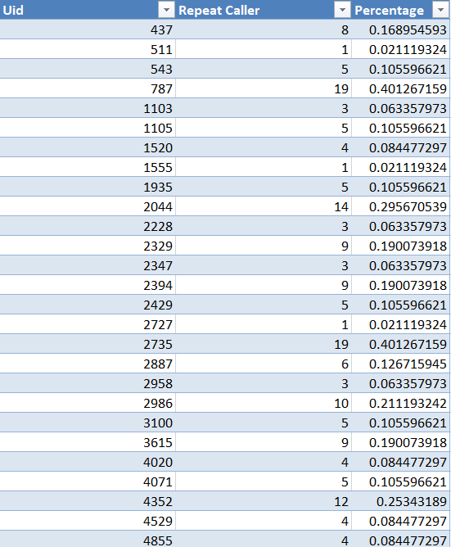

Total percentage of calls is 55.63%

Count of Repeat Callers is 1276

1. **What is the total sales generated by the call centre for each product category?**

**Ans.** Total sales generated by call is 168442, from chat is 45494 and from complimentary chat is 50.(All values are approximate).

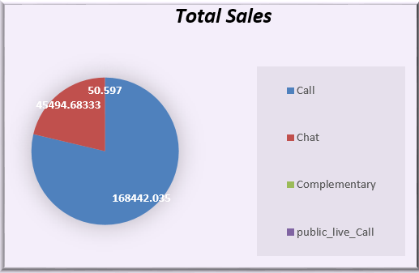

1. **How many calls were made for each user ID and guru ID?**

**Ans.** 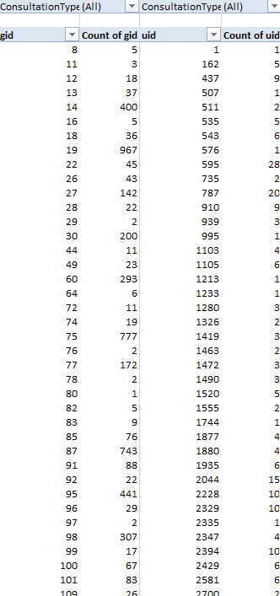

1. **What is the correlation between call duration and customer satisfaction?**

**Ans.** The correlation between call duration and customer satisfaction is 0.81.

Formula used to find the correlation is =CORREL(Rating column[for calls] **:** Sum of call duration column)

1. **Which guru have the highest and lowest customer satisfaction scores?**

**Ans.** Astro Pujaa Rai and Tarot Mystical have the highest customer satisfaction and Tarot Ritikka have the lowest satisfaction score.

1. **What is the average customer satisfaction score by month?**

**Ans**. In Jan it is 2.6 while in dec it is 2.9 average rating score.

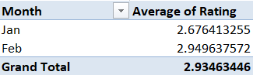

1. **How many categorical columns are there in the data?**

**Ans.** 13 number of categorical columns are there in data

**Subjective Question:**

**Q1**. **Should the investment be used to hire more agents, improve training programs, or upgrade call center technology?**

**Ans.**

1. **Hiring More Agents:**

***Data Insight:*** According to the data, a significant number of 0-rated gurus suggests there may be a skill or quality issue among existing agents. Additionally, the volume of call users is high compared to chat users, indicating a need for effective call handling.

The data shows long wait times and high call volume during peak periods

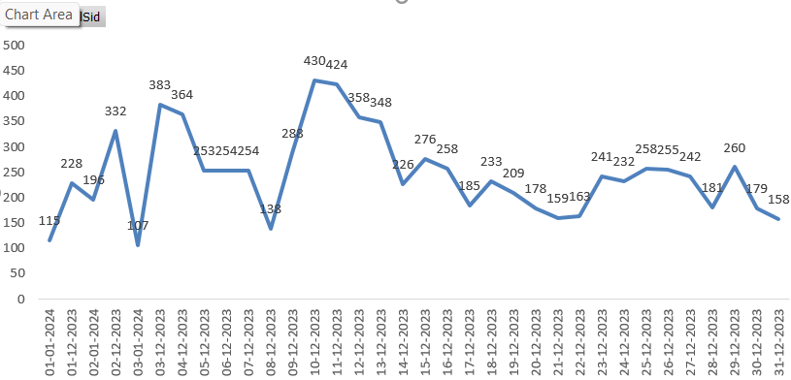

***Recommendation:*** Invest in hiring skilled agents selectively rather than in bulk.

The investment should be used to hire more agents, but simply hiring more agents without improving systems or training could lead to inefficiency and increased operational costs. We should focus on specific things such as improving the training program. This would improve customer experience and reduce the number of low-rated interactions.

**2. Improving Training Programs:**

Data Insight: The high number of 0-rated gurus and the performance gap in calls vs. chats indicate potential gaps in skill and service quality. Proper training tailored to enhance skills for both new and existing agents would likely reduce customer dissatisfaction.

From the data it can be clearly seen that average rating is very less for gurus

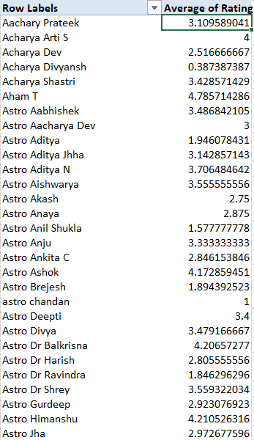

***Recommendation****:* Allocate a portion of the investment toward specialized training programs focusing on quality improvements for call handling and customer satisfaction.

**3. Upgrading Call Center Technology:**

Data Insight: The data shows fewer chat users, suggesting a possible technology gap that discourages chat usage. Upgrading technology, particularly for chat functions, could make agent interactions smoother, enhance productivity, and reduce wait times for both chat and call users.

Recommendation: Consider investing in call and chat technology to facilitate seamless connections, which could ultimately improve user engagement and agent efficiency.

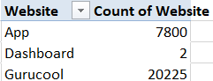 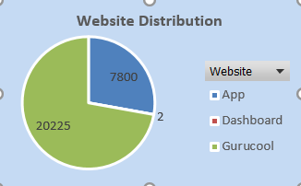

**Final Recommendation:** Based on the analysis, the primary investment should focus on hiring skilled agents and enhancing training programs to reduce the number of 0-rated gurus and improve call handling quality. Additionally, upgrading technology is essential to encourage chat engagement

**Q2. What are the potential risks of each investment option (hiring, training, technology upgrades), and how can they be mitigated?Name the chart/spreadsheet function you will use for solving the problem?**

**Ans.**

***1. Hiring***

***Risks:***

* Over-hiring: Hiring too many agents can lead to higher operational costs if call volume doesn't justify the increased staffing.
* Inadequate Training: New agents might not be properly trained, leading to lower customer satisfaction and productivity.

***Mitigation Strategies:***

* Forecasting: Conduct thorough demand forecasting using historical data to predict future call volume and avoid over-hiring.
* Hiring Process: Implement a rigorous hiring process that includes skills testing, personality assessments, and interviews to ensure new hires align with the call center's culture and values.

***2. Training***

***Risks:***

* Ineffective Training: Training programs might not be engaging, relevant, or effective in improving skills.
* Inadequate Resources: Insufficient time, resources, or qualified trainers can hinder the effectiveness of training.

***Mitigation Strategies:***

* Assessment: Identify specific skills and knowledge gaps among agents to train them accordingly. Conduct assesments on regular basis.
* Effective Training Methods: Utilize interactive training methods like group discussions to improve engagement and knowledge retention.

***3. Upgrading Call Center Technology***

***Risks:***

* High Costs: Technology upgrades can involve significant initial investments, which might not be feasible for all organizations.
* Integration Issues: New technologies might not integrate seamlessly with existing systems, leading to compatibility problems.

***Mitigation Strategies:***

* Cost-Benefit Analysis: Conduct a thorough cost-benefit analysis to justify the investment and ensure a positive return on investment.
* Thorough Testing: Conduct thorough testing of new technologies with existing systems to ensure compatibility and identify any potential integration challenges before implementation.

Charts and functions that will be used to solve the problems are:-

***Charts -***

Line Charts: It will be used for visualising trends over time, such as call volume or customer satisfaction scores.

Pie Charts: Ideal for showing parts of a whole, like total sales generated, Total call duration etc.

Scatter Plots: Great for exploring the relationship between two variables, such as call duration and customer satisfaction.

Pivot Tables: Allow for interactive data aggregation and analysis, making it easier to filter, sort, and summarize data.

***Functions -***

COUNTIFS: To count calls handled by a specific agent on a specific day: =COUNTIFS(AgentID_Column, "Agent1", Day_Column, "Monday")

MAX, MIN: To find the maximum and minimum customer rating for guru: =MAX(Rating_Column)

WEEKDAY: Extracts the day of the week from a date (e.g., "Monday", "Tuesday").

=WEEKDAY(Date_Column)

CORREL: To find the correlation between call duration and customer satisfaction: =CORREL(CallDuration_Column, Satisfaction_Column)

**Q3. How does AstroSage call center performance compare to that of AstroGuru in terms of average call volume, customer satisfaction, and agent performance?Will you use any aggregation function or a visualization here to solve the problem?**

Ans.

AstroSage call centre performance compare to that of Astro Guru in terms of average call volume is good but its average in terms of Customer satisfaction and somewhat good in terms of agent performance.

I have used visualization here with the help of pivot tables, charts and slicers because it can easily compare the key performance indicators of AstroSage and AstroGuru, enabling you to identify areas where AstroSage can potentially improve.

Customer Satisfaction can be analyzed using below chart:-

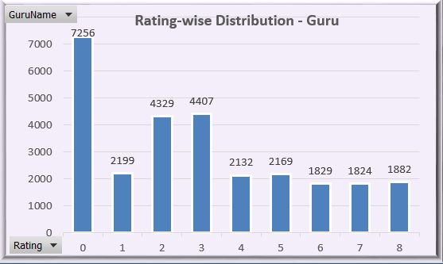

Average call volume can be analyzed using below chart:-

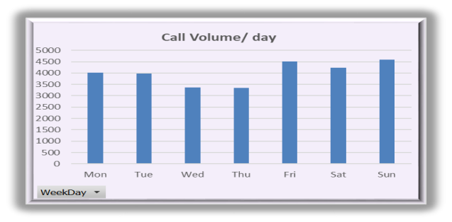

**Q4. How can the call center improve its handling of peak call periods to ensure high customer satisfaction?**

**Mention the functionality which you will use for giving the suggestions, will it be any aggregated function or a visualization?**

**Ans.**

First step is to identify the peak call period which can be achieved through both using visualization and function

*Function*: Use COUNTIFS, Hour function (to extract hour) and a pivot table to count the number of calls received during each hour of the day and each day of the week.

*Visualization:* Create a line chart (using conditional formatting)to visualize the call volume patterns across hours and Call volume.This will clearly show the peak periods.

* **Reference:-** Pivot table/ dashboard

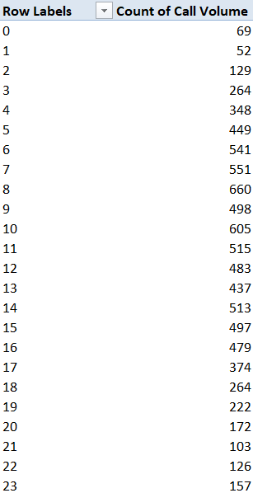 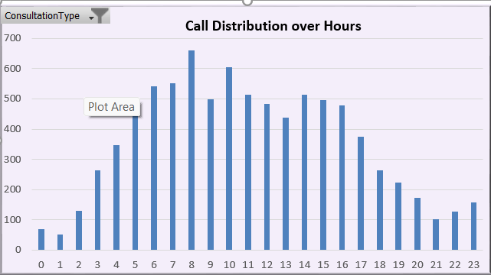

Now methods to handle these situations are:-

***Optimize Staffing:***

Visualization: Use a pivot table or bar chart to compare the average call volume during peak periods to the average volume during non-peak periods.

***Implement Call Routing Systems:***

Function: Use COUNTIFS or a pivot table to count the number of calls directed to each agent during peak periods.

***Enhance Agent Training:***

Function: Analyze average call durations and customer satisfaction scores during peak periods.

Visualization: Create charts (bar charts or scatter plots) comparing average call duration and customer satisfaction scores during peak and non-peak periods.

**Monitoring:**

Visualization: Use charts and pivot tables to track metrics like call volume, wait times, and customer satisfaction scores over time.

**Q5. Based on historical data, what strategic initiatives should be prioritized to improve overall efficiency and customer satisfaction?**

**Ans.**

We can use call volume data of Astrosage to optimize scheduling and staffing.

1**Optimize Staffing During High-Volume Hours:**

From the chart, the highest call volume (1,875 calls) is handled during the 8th hour, while consistently high volumes are handled from the 5th to 17th hours. This suggests that these intervals experience the greatest demand. To manage this, more agents should be scheduled to work during these high-demand hours to prevent long wait times and improve efficiency.

**Introduce Call-back Options During Peak Demand:**

During intervals with high call volumes (e.g., 6th to 17th hours), wait times may become an issue. Implementing a call-back option during these high-volume periods would allow customers to request a call-back instead of waiting on hold, improving their experience without overwhelming the staff.

**Enhance Self-Service Features:**

The significant call volumes during the 5th to 17th hours indicate that many inquiries are handled within these periods. By expanding self-service options such as chatbots or an FAQ knowledge base, routine customer issues can be resolved automatically, reducing the pressure on agents and allowing them to handle more complex problems.

**Leverage Data for Personalization:**

During peak hours, offering agents access to customer history, preferences, and past interactions can speed up call handling and provide more personalized service. This would be particularly effective during high-volume hours, where efficiency and customer satisfaction are both priorities.

Targeted Training for Peak Hours:

Given that the highest call volumes are consistently seen during specific intervals (e.g., 6th to 17th hours), agents working during these hours should receive specialized training to handle higher workloads and stressful situations. This would improve both the quality of service and agent morale during peak periods.

**Reference:-** Pivot chart



**Q6. What can be the key factors contributing to high customer satisfaction scores, and how can these be leveraged to improve overall performance?**

**What is the basis for the suggestions? And mention how did you decide if the satisfaction score affect the ratings?**

**Ans.**

Following are the key factors contributing to high customer satisfaction scores:-

***Agent Behaviour:-***Customers appreciate agents who are friendly, polite, and empathetic. This creates a positive experience, even when dealing with challenging issues.

***Leverage:-*** Develop training programs to equip agents with effective communication skills, active listening techniques, and empathy-building strategies.

* Recognition: Recognize and reward agents who consistently demonstrate excellent communication skills and empathy.

***On-Time Response:-*** Customers value a prompt response. Long wait times are a major source of frustration.

***Leverage:-*** Adjust staffing levels to accommodate peak call volumes.

* Call Routing: Implement a call routing system that prioritizes urgent calls.
* Virtual Queues: Offer virtual queues to allow customers to hold their place in line without staying on the phone.

***Resolution:-*** Customers appreciate being informed about the resolution of their issues.

***Leverage:-*** Active Communication: Reach out to customers if their issue requires additional steps or follow-up.

Customer Feedback: Customer feedback after the call to understand if the issue was resolved to their satisfaction.

***Basis for the suggestions:-***

Through analysis of data and analysing charts.

As we can see in chart customer are giving bad ratings to gurus and mostly in call status section so improvement in agents and call services is needed.

Common Sense and Customer Perspective:

Some suggestions are based on common sense and a customer-centric approach. For example, it's clear that customers appreciate clear communication, prompt responses, and a sense of being valued.

Putting ourselves in place of customers: Consider how we would feel if we were a customer calling a call center. This can help identify areas where the experience might be frustrating or could be improved.

***How Satisfaction Scores Affect Ratings:***

* Direct Correlation: Customer satisfaction scores are often used directly to calculate overall ratings. For example, a customer might be asked to rate their experience on a scale of 1 to 5, and their response directly impacts the overall rating.
* Indirect Influence: Even if satisfaction scores aren't directly used in a rating calculation, they can still influence customer perception. A customer who has a positive experience is more likely to give a high rating, even if they aren't specifically asked about their satisfaction.
* **Reference:-** Pivot chart

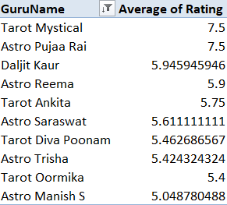 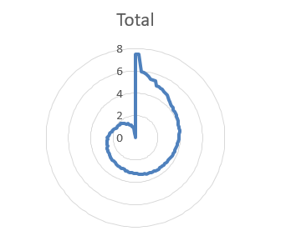

**Q7. How should the call center balance the workload among agents to ensure optimal performance and avoid burnout?Mention your approach and spreadsheet function for the answer?**

**Ans.**

• If agents are handling a very high number of calls per day (indicating a heavy workload), it may signal the need for hiring more agents, providing additional support, or improving processes.

• Conversely, if agents are handling a very low number of calls per day, it could indicate inefficiency or overstaffing, which could be costing the business in unnecessary expenses.

It helps to measure the productivity of agents. If an agent can efficiently handle many calls with high customer satisfaction, it shows a productive workforce. However, if the number is too high, the quality of service may decrease, leading to burnout or lower customer satisfaction.

• Based on this metric, the call centre management can determine if they need to hire more agents or if existing agents can handle the current volume effectively.

• It also helps in scheduling - if some days see spikes in call volumes, more agents may need to be scheduled for those days.

**Q8. What new technologies or tools could be implemented to enhance call center operations and customer service?**

**Ans.**

Some of the technologies or tools that could be implemented to enhance operations are:-

* By implementing Ai-powered chatbots. Benefits are 24/7 availibility and also its capacity to handle large volume.
* By managing Customer Relationship Management (CRM) Systems:

It Stores all customer information in one place (e.g., contact details, purchase history, interactions).Also, use customer data to personalize interactions and offer tailored solutions.Agent Empowerment: Provide agents with relevant customer information to handle inquiries more effectively.

**Q9. What metrics should be included in the final dashboard to provide a comprehensive view of call center performance and guide investment decisions?**

Ans.

***Call Volume and Handling Metric:***

Average Daily Call Volume: Track the average number of calls received each day to monitor overall call volume trends.

Peak Hours: Highlight peak hours with the highest call volume to understand staffing needs.

Calls Abandoned: Monitor the percentage of calls abandoned before being answered. This indicates potential problems with wait times.

* **Reference:-** Pivot chart

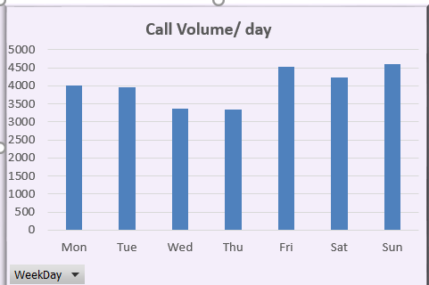

1. ***Customer Satisfaction Metrics***

* **Reference:-** Pivot chart

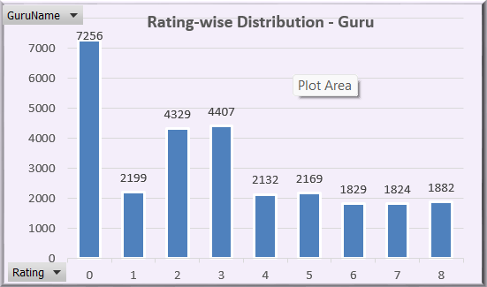

***3. Agent Performance Metrics:***

Calls Handled Per Agent: Track the average number of calls handled by each agent per day.

Average Call Duration: Track the average duration of calls handled by each agent to gauge efficiency.

Customer Feedback Ratings: Display the average customer satisfaction score for each agent.

***4. Financial Metrics:***

Total Revenue Generated and total operational cost

* **Reference:-** Pivot chart

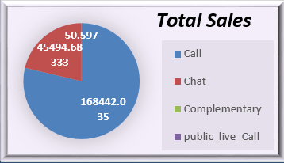

***5. Visualizations:***

Charts: Use line charts to display trends over time, bar charts for comparisons for visualizing patterns.

Pivot Tables: Use pivot tables to allow for interactive analysis and filtering of data.

**Q10. How would you allocate a 1 crore rupee investment to optimize operational efficiency, enhance customer satisfaction, and boost profitability, and what analysis-based recommendations would you offer to support this?**

**Ans.**

I would allocate a 1 crore rupee investment in the following ways:-

* ***Agent Training and Development (40%)***:

This is crucial for improving customer satisfaction and agent efficiency.

* *Customized Training:* Invest in training programs tailored to specific needs identified in data analysis (e.g., communication skills, product knowledge, handling complex issues).
* *Mentorship Programs:* Establish a mentorship program where senior agents coach newer agents.
* ***Technology Upgrades (30%):***

Invest in technology to automate tasks, streamline processes, and improve the customer experience.

* *CRM System:* Invest in a robust CRM system to centralize customer data, personalize interactions, and provide agents with relevant information.
* *Call Routing System:* Implement an automated call routing system to distribute calls efficiently based on skills and availability.
* *AI-Powered Chatbot*: Consider a chatbot to handle routine inquiries and free up agents for complex issues.
* ***Staffing and Scheduling Optimization (20%):***
* Optimize staff allocation and scheduling based on data-driven insights.
* Ensure flexible work ours according to needs and agent best-fit, potentially leading to higher engagement and retention.
* **Customer Feedback & Analysis (10%)**:

Invest in tools and processes to capture and analyze customer feedback.

* Post-Call Surveys: Implement post-call surveys to collect immediate feedback from customers.
* Social Media Monitoring: Use tools to track customer sentiment on social media platforms.
* **Analysis-Based Recommendations:**
* Training Focus: Prioritize training on skills identified through data analysis, such as communication techniques, product knowledge, and problem-solving strategies. Pay special attention to areas where customer satisfaction scores are low.
* CRM System Implementation
* Continuous Feedback: Establish a robust customer feedback loop. Use customer feedback, call recordings, and data analysis to continuously improve agent performance, training programs, and call center processes.